SIMATS ENGINEERING
ASSESSMENT TOOL 3

COURSE NAME: Artificial Intelligence COURSE CODE: CSA1707

COURSE OUTCOME COVERED

CO2: Experiment search and game-solving techniques such as Greedy Search, A*, CSP, Minimax, and Alpha-Beta pruning with heuristic functions for solving complex AI problems efficiently. (BL3)

Assessment Tool Weightage: 40%

Duration: 1 Hour
QUESTIONS: 3 Total Marks:30

Annexure A

Dry Run Evaluation

Code of Conduct:

I B. PRADEEP KUMAR 1925260156 (Name / Reg No) certify that this submission is my original work and that I have adhered to the guidelines specified for this assessment.
I understand that any violation of academic integrity rules will result in disciplinary action.

Signature of the student: B. Pradeep Kumar

Annexure A

Dry Run Evaluation
1. Question 1 – Breadth-First Search (BFS)
Consider the following graph: A
/ \
B C
/ \ / \
D E F G
Task: Starting from node A, perform a Breadth-First Search (BFS). Complete the following table.
Iteration | Queue | Visited Node
1
2
3
4
5
6
7
Questions:
- Write the BFS traversal order.
- Show the queue contents after each iteration.
Given graph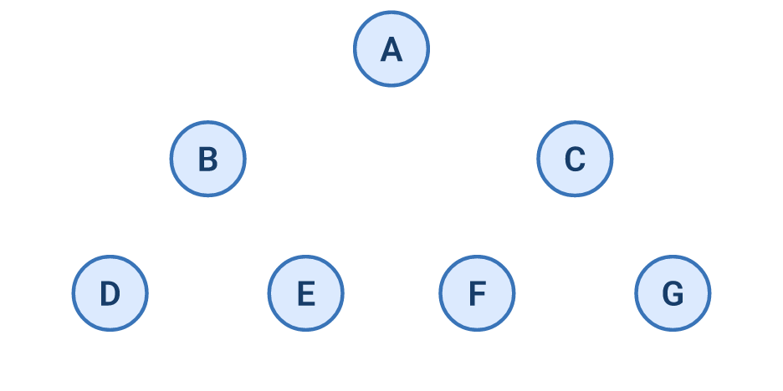
BFS algorithm: Visit nodes level by level using a queue.
Dry-run table
Iteration Queue (after expansion) Visited node
1 B, C A
2 C, D, E. B
3 D, E, F, G C
4 E, F, G D
5 F, G E
6 G F
7 Empty G
1. BFS traversal order
A → B → C → D → E → F → G
2. Queue contents after each iteration
Initially: [A]
After visiting A: [B, C]
After visiting B: [C, D, E]
After visiting C: [D, E, F, G]
After visiting D: [E, F, G]
After visiting E: [F, G]
After visiting F: [G]
After visiting G: []


2. Depth-First Search (DFS) Using the same graph,
A
/ \
B C
/ \ / \
D E F G
Perform Depth-First Search (DFS) starting from A.
DFS algorithm: Visit a node and explore its descendants as deeply as possible before backtracking. Assume left-to-right traversal.
Dry-run table
Iteration Node visited Stack (top at right)
1 . A C, B
2 B C, E, D
3 D C, E
4 E C
5 C G, F
6 F G
7 G Empty
DFS traversal order
A → B → D → E → C → F → G
Explanation: DFS starts at A, visits B, goes to D, backtracks to E, then visits C, F, and G.
Note: The stack representation above assumes the next node to visit is on the right; implementations may display the stack in a different order.

Complete the table.
- Initial State :
1 3 6
5 0 2
4 7 8

Goal State :
1 2 3
4 5 6
7 8 0

Task
Trace Breadth-First Search (BFS) until the goal state is reached.
Fill in the table.
Iteration | Current State | Queue Before Expansion | Queue After Expansion
1
2
3
4
5

Questions
- Which node is expanded in each iteration?
- How many states are generated in total?
- Write the complete solution path from the initial state to the goal state.
- Why does BFS always find the shortest solution in an unweighted 8-puzzle problem?
Initial state
1 3. 6
5 _ 2
4. 7 8

Goal state
1 2 3
4 5 6
7 8 _
Important: The initial and goal configurations in the question paper have different inversion parity. Therefore, the goal is unreachable from the given initial state under the standard 8-puzzle rules. BFS cannot reach it.

Dry-run table
The first five BFS expansions are shown below. For a consistent order, blank moves are generated as Up, Down, Left, Right whenever legal.

Iteration Current state expanded Queue before expansion Queue after expansion

1 Initial state [S₀] [S₁, S₂, S₃, S₄]

2 S₁ [S₁, S₂, S₃, S₄] Remaining states + children of S₁

3 S₂ Pending states Remaining states + b. children of S₂

4 S₃ Pending states Remaining states + b . children of S₃

5 S₄ Pending states Remaining states + children of S₄

Here, S0 is the initial state and S1,S2..... are generated states. Exact queue contents depend on the order in which legal moves are generated

Answers to the questions

1. Which node is expanded in each iteration?

BFS expands states in FIFO order (first in, first out), starting with the initial state.

2. How many states are generated in total?
BFS cannot reach the specified goal. The exact number of unique reachable states depends on duplicate-state detection; the standard 8-puzzle state space contains 181,440 states in the same parity class as a given configuration.

3. Write the complete solution path.

No solution path exists for the given initial and goal states because the puzzle is unsolvable as written.

4. Why does BFS always find the shortest solution in an unweighted 8-puzzle problem?

BFS explores states in increasing order of depth. Every move has equal cost, so the first time BFS reaches the goal, it has used the minimum possible number of moves.

Submission tip: For Question 3, mention the unsolvability clearly. If the initial state or goal state contains a typing error, correct it with your instructor before attempting a full solution path.

RUBRICS FOR CALCULATION

Criteria | Weightage (%) | Level 4 – Exemplary (4) | Level 3 – Proficient (3) | Level 2 – Developing (2) | Level 1 – Beginning (1)
Understanding of Search Problem | 20 | Clearly understands the search problem, initial state, goal state, and search strategy. | Understands the problem with minor misunderstandings. | Demonstrates partial understanding of the search problem. | Shows little or no understanding of the search problem.
State Expansion and Dry Run Execution | 30 | Correctly traces every iteration, expands nodes accurately, and maintains the Queue/Stack/Priority Queue without errors. | Performs most iterations correctly with minor mistakes in state expansion or data structure updates. | Performs only some iterations correctly; several errors in tracing or node expansion. | Unable to correctly perform the dry run or expand states.
Application of Search Algorithm | 20 | Applies the selected algorithm (BFS/DFS/UCS) correctly, following all algorithmic rules. | Applies the algorithm correctly with a few procedural errors. | Applies only basic algorithm steps with noticeable mistakes. | Fails to apply the correct search algorithm.
Accuracy of Solution Path | 20 | Identifies the correct traversal order/solution path and goal state with proper justification. | Solution path is mostly correct with minor errors. | Partially correct solution path; goal may not be reached correctly. | Incorrect or incomplete solution path.
Presentation and Logical Reasoning | 10 | Queue/Stack/Priority Queue updates, state diagrams, and explanations are neat, organized, and logically presented. | Presentation is clear with minor organizational issues. | Limited explanation and organization; reasoning is partially clear. | Poor presentation with unclear or missing reasoning.

